

Easy!AppointmentS

Backend Documentation

07/10/2020 |

Prepared for Josh Griggs by Tom Woodward and Lloreli Sigua

**Requirements:**  
The user needs to have set up an easy appointments account before beginning (and an internet connection and power supply) **Introduction:**  
[Easy!Appointments](http://52.23.162.78/S4AppointmentsPT2/) is a web application for customers to book their own appointments at for a variety of business services and providers. The software is hosted on a cloud-based service provider and is accessible to anyone with an internet connection.

Contents

Front End Section 3

Login: 3

Calendar: 4

Select Service: 5

Select date and time: 6

Customer information: 7

Confirm appointment: 8

Navigate back to calendar: 9

Back End Section 10

Calendar: 10

Select appointment and edit: 12

Edit appointment: 13

Add customer: 13

Check or edit customer details: 14

Services 14

Add services 14

Check or edit service: 15

Check/Edit providers details: 16

Settings General: 17

Settings business logic: 17

Settings legal contracts: 18

Settings Current User: 19

Settings About Easy Appointments: 19

# Front End Section

## Login:

Enter username and password then click Login. This will take you to the calendar page.

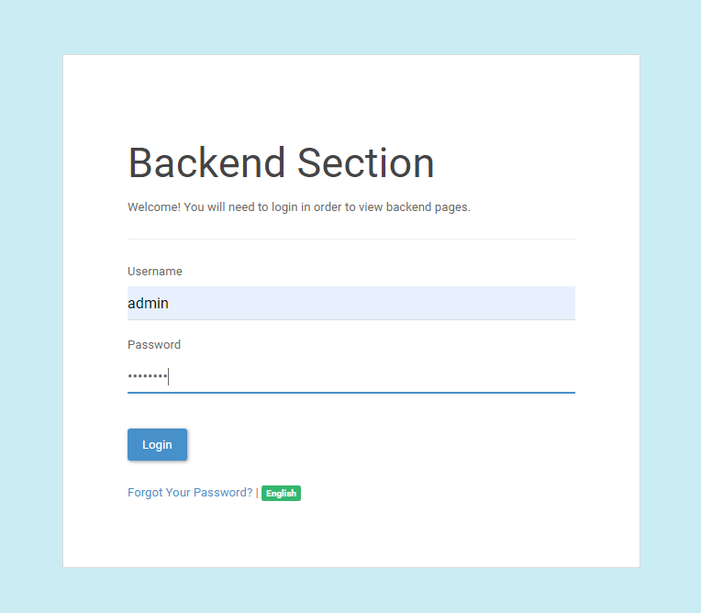

Calendar:  
In the calendar page click on go to booking page at the bottom. This will take you to the first page of the booking page.  
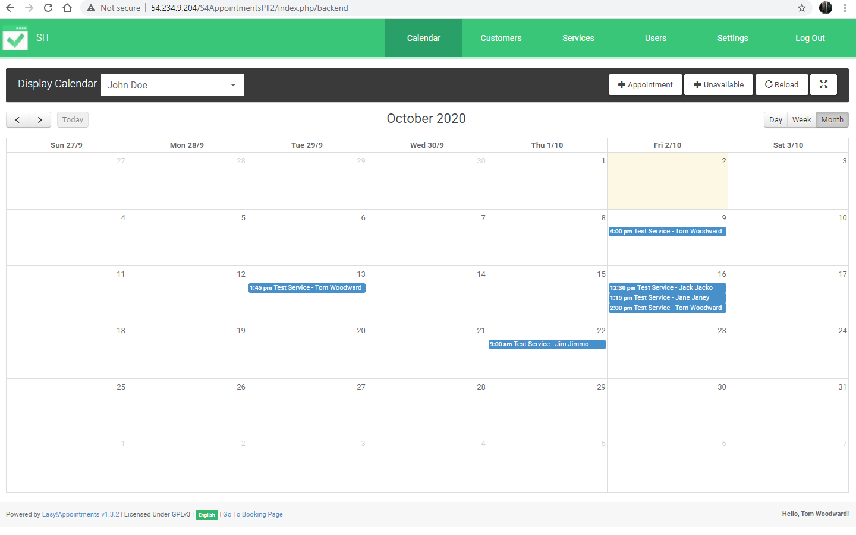

Go to Booking Page

Select Service:  
The first page of the booking page is indicated by the number 1 in the top right. On this page select service and provider, then click next. This will take you to page 2 to select date and time.  
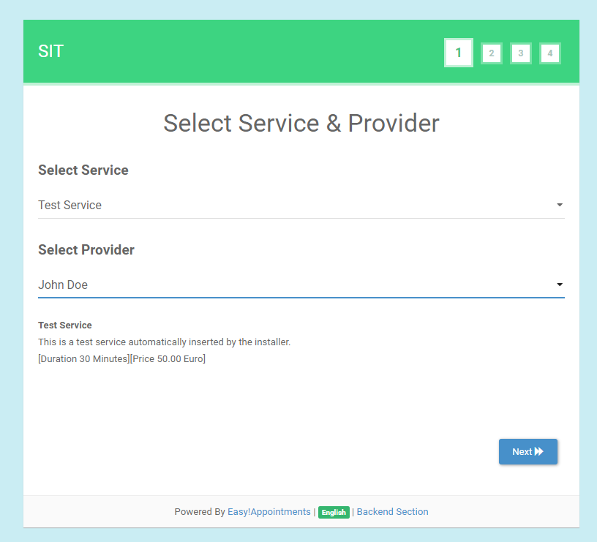

Select date and time:  
In the select date and time page select the desired date on the left, then select the desired time on the right. Once date and time are selected, click next on the bottom right. This will take you to the customer information page.  
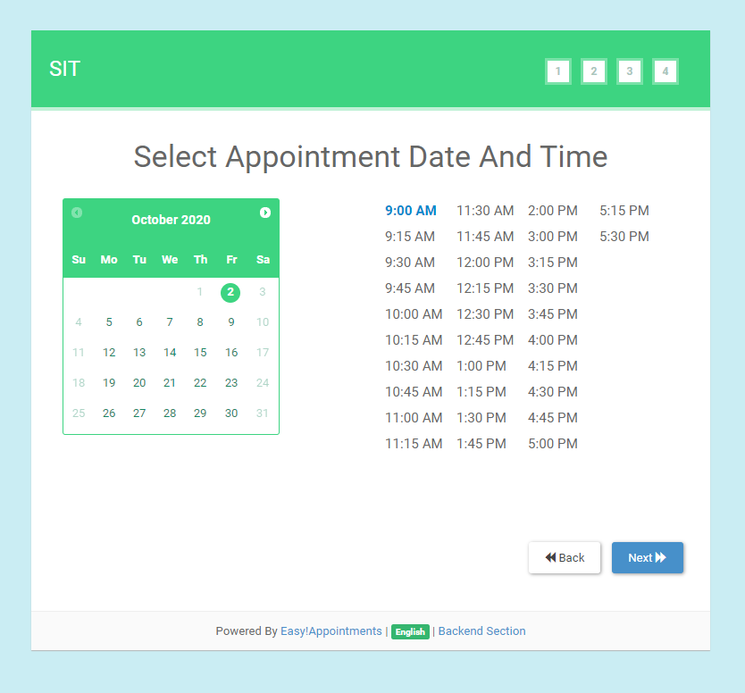

Customer information:  
In the customer information page you must fill in the fields indicated by *. Fill in first name, last name, email address and phone number. If desired you can fill in address, city, zip/post code and add a note. Once complete click next on the bottom right, this will take you to the confirm appointment page.  
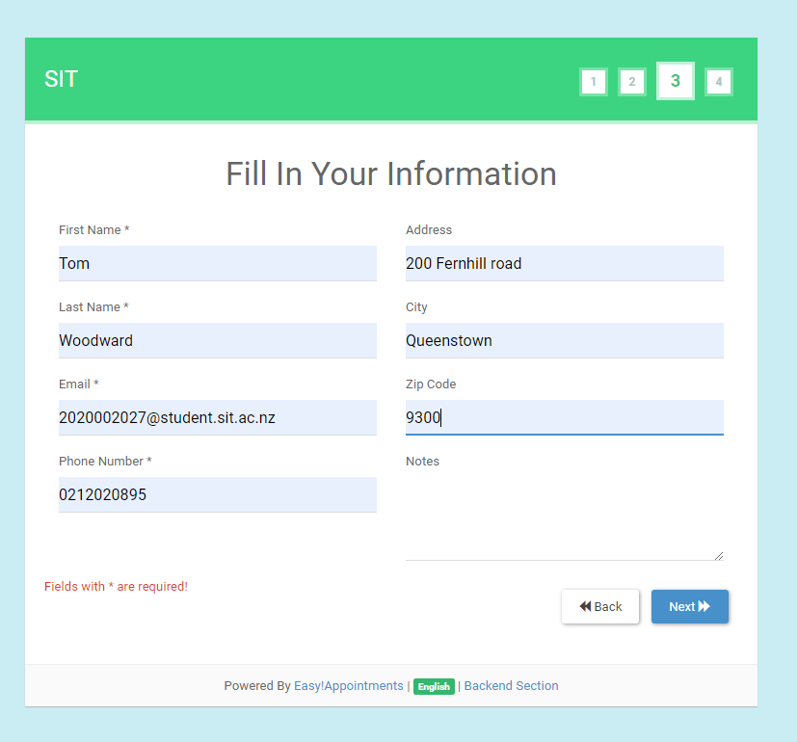

Confirm appointment:  
Verify details and click confirm in the bottom right. This will take you to the registration page.  
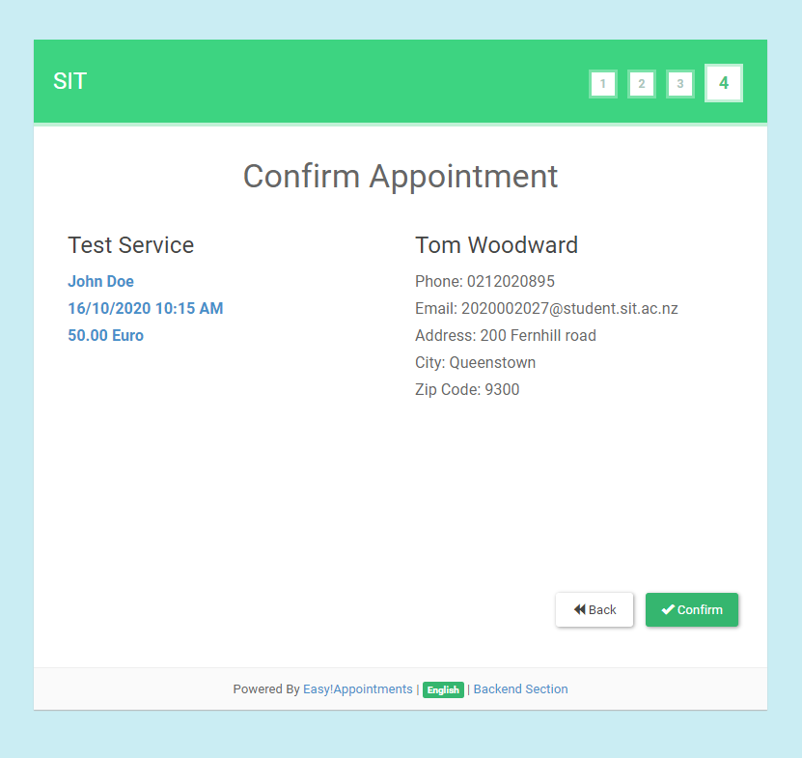

Appointment registration:  
Click go to booking page.  
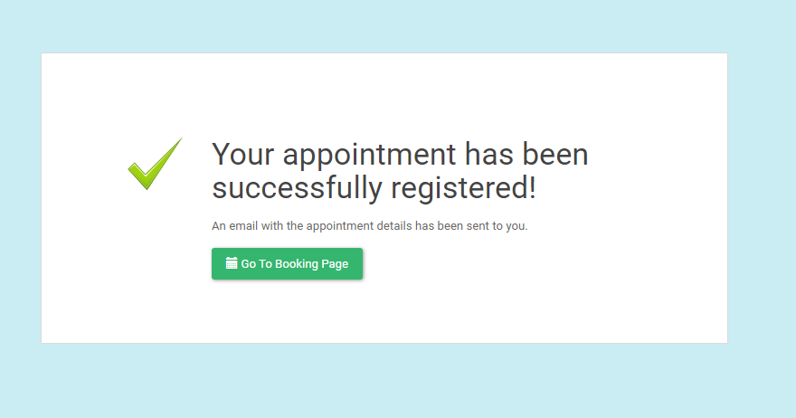

Navigate back to calendar:  
Click on backend section at the bottom, this will take you back to the calendar page.  
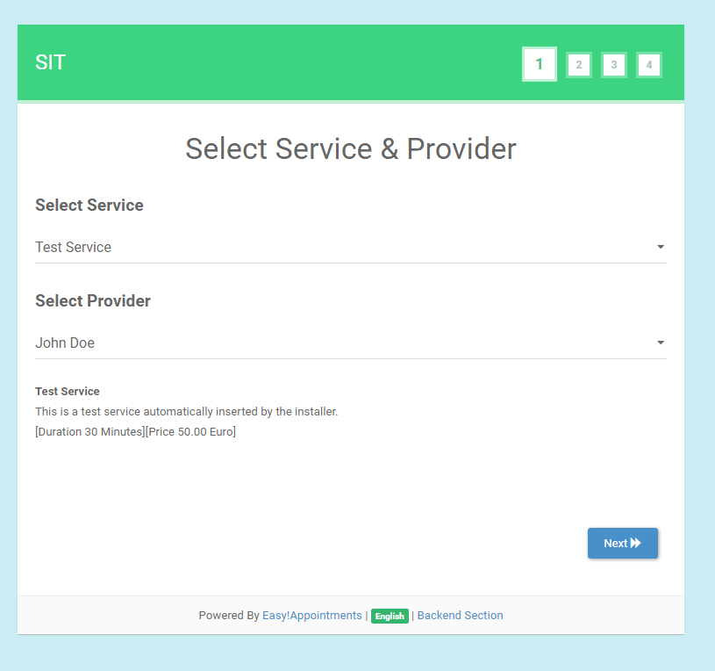

Go to backend section

# Back End Section

Calendar:  
In the calendar page check you can also make an appointment in the backend. Click on the +Appointment button in the top right. This will bring up the New Appointment page.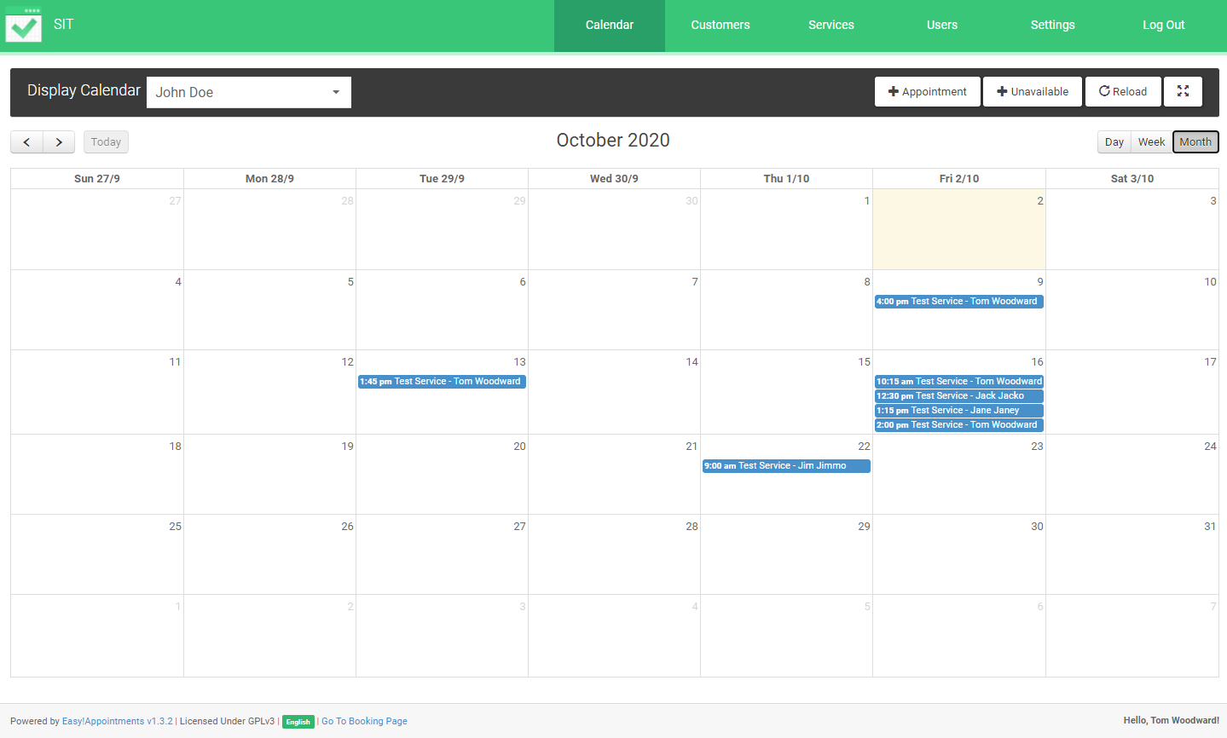

Add Appointment

Create new appointment:  
Select the service, provider, date and time of the appointment you want to make. Next fill in your details in the bottom section. You can add notes if required. You can alter customer details if required. Click Save at the bottom right when changes have been made.  
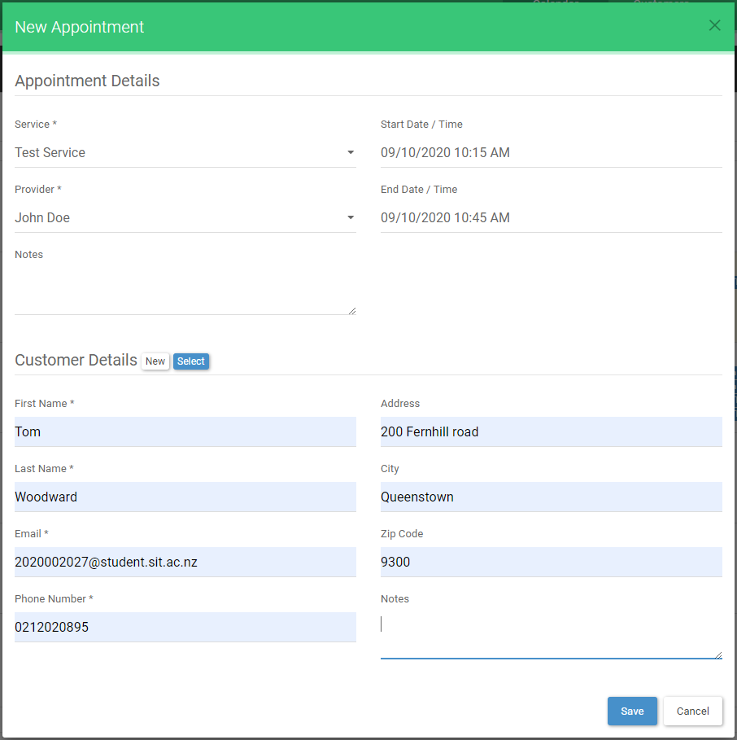

Select appointment and edit:  
Click on appropriate appointment to see appointment details then click the Edit button.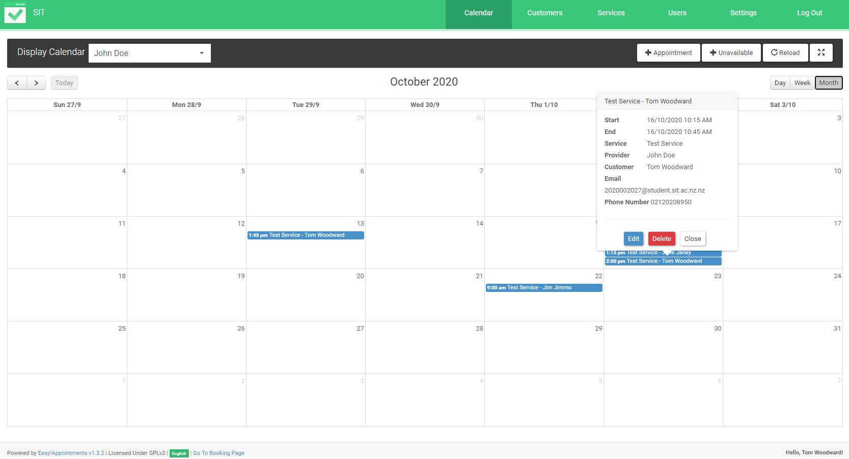

Edit

Edit appointment:  
In the edit page add or change the details of the appointment. Click save at the bottom right when changes have been made.  
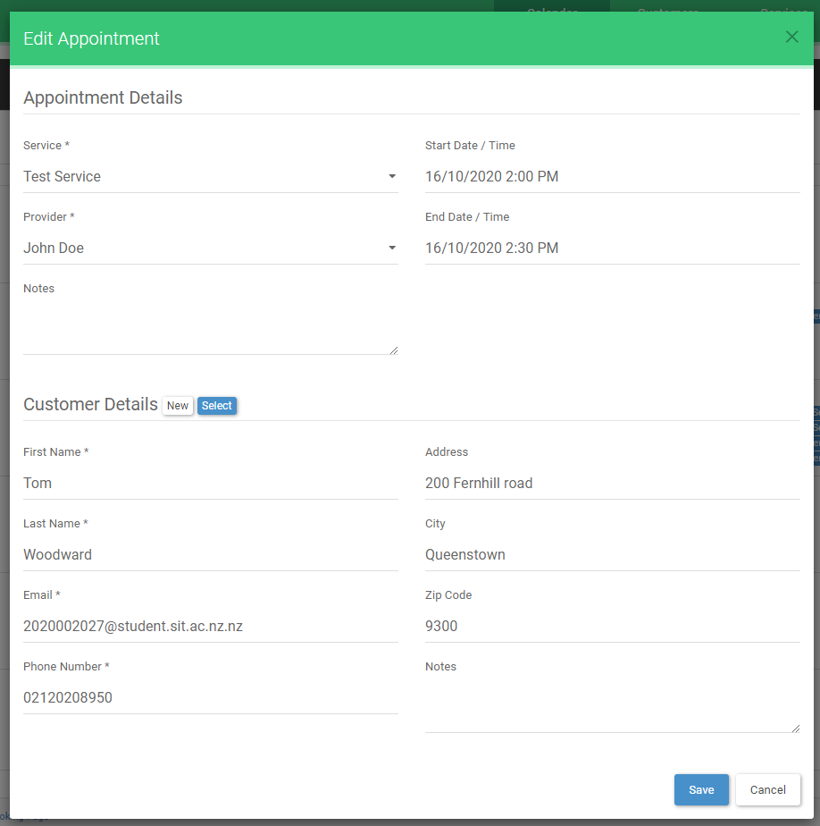

## Add customer:

Click Customers at the top of the screen, this will bring up the Customers page. Click the blue +Add button in the top left. Below fill out the information fields with customer details. First name, Last name, email, phone number, address, city, zip/post code. Fields with a * are required.

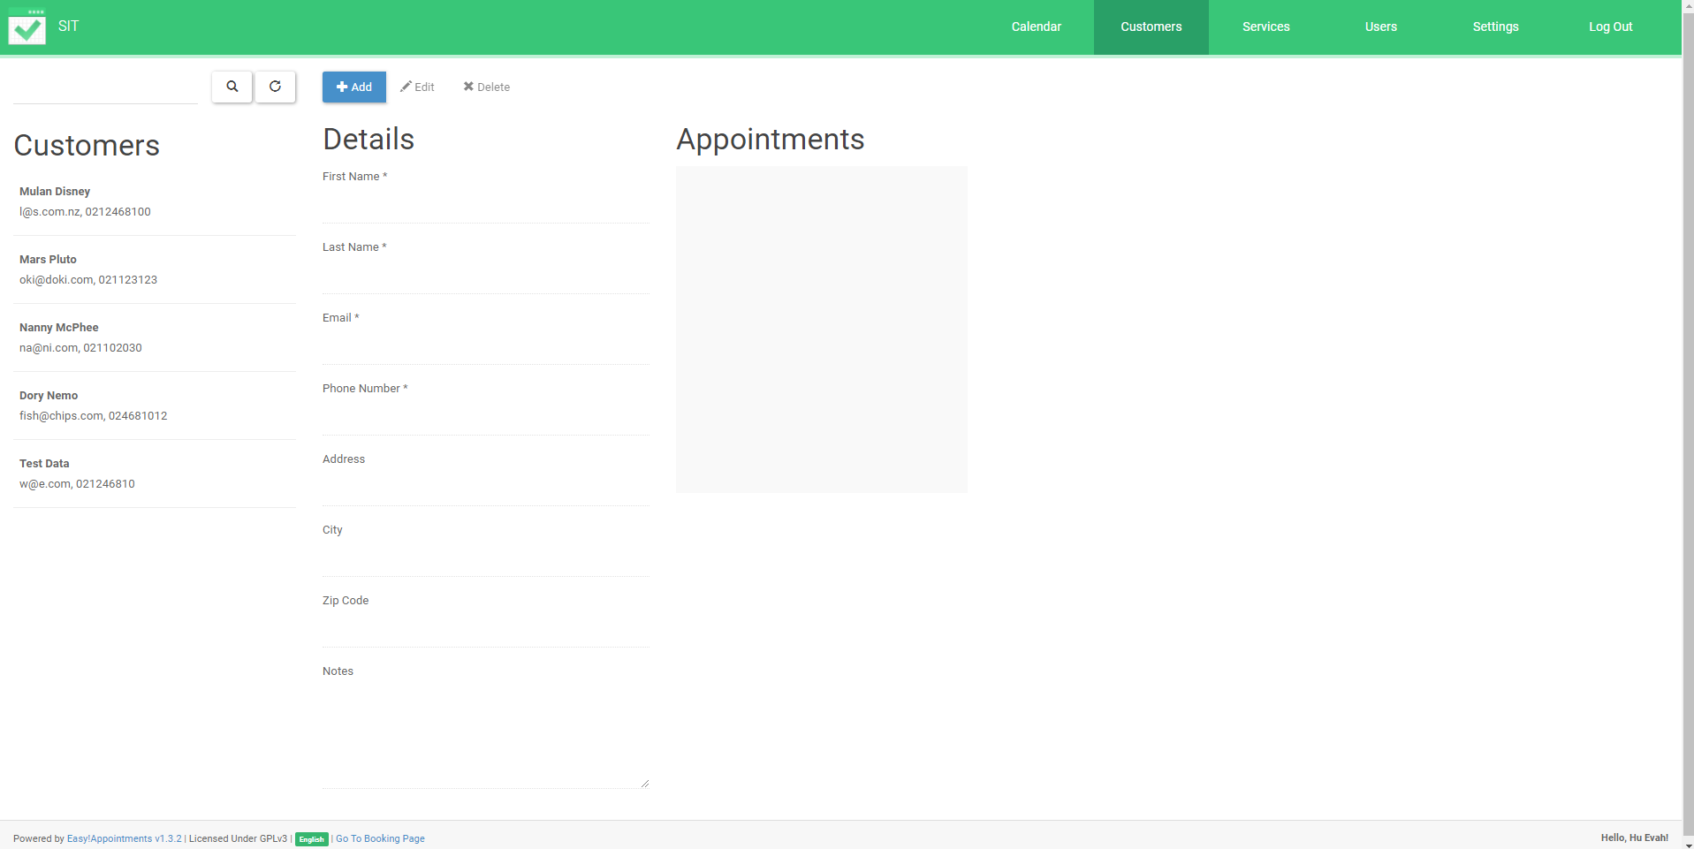

Customers Button

Add Customer

## Check or edit customer details:

Click on the previously added customers on the left. This will populate the fields with the details of the saved customers. Check and edit the customer details then click save if any changes are made. Blue +Add button will change to Save button when information is added or edited.  
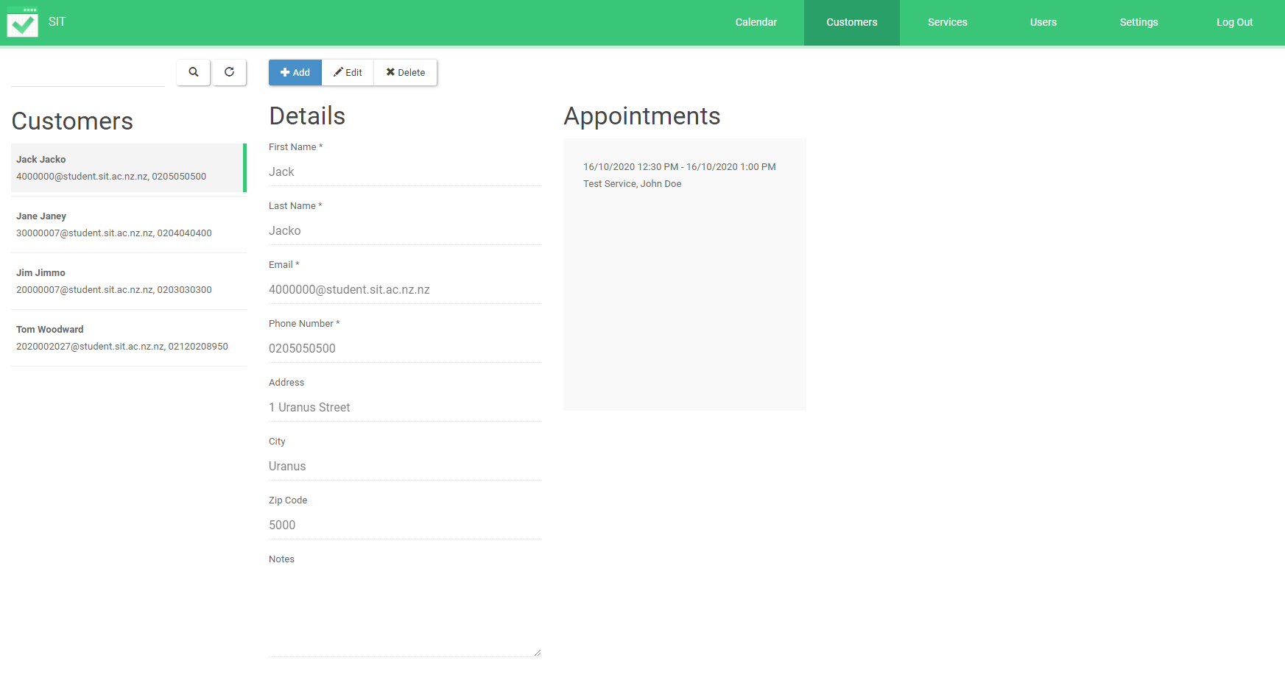

# 

# Services

Add services:

Click on Services in the top of the screen. This will bring the user to the Services page. Click +Add at the top of this page. The service details can now be added. Name, Duration, Price, Currency, Category, Type, Attendants Number, Description. Fields with a * are required. Click save when changes are made. Blue +Add button will change to Save button when information is added or edited. 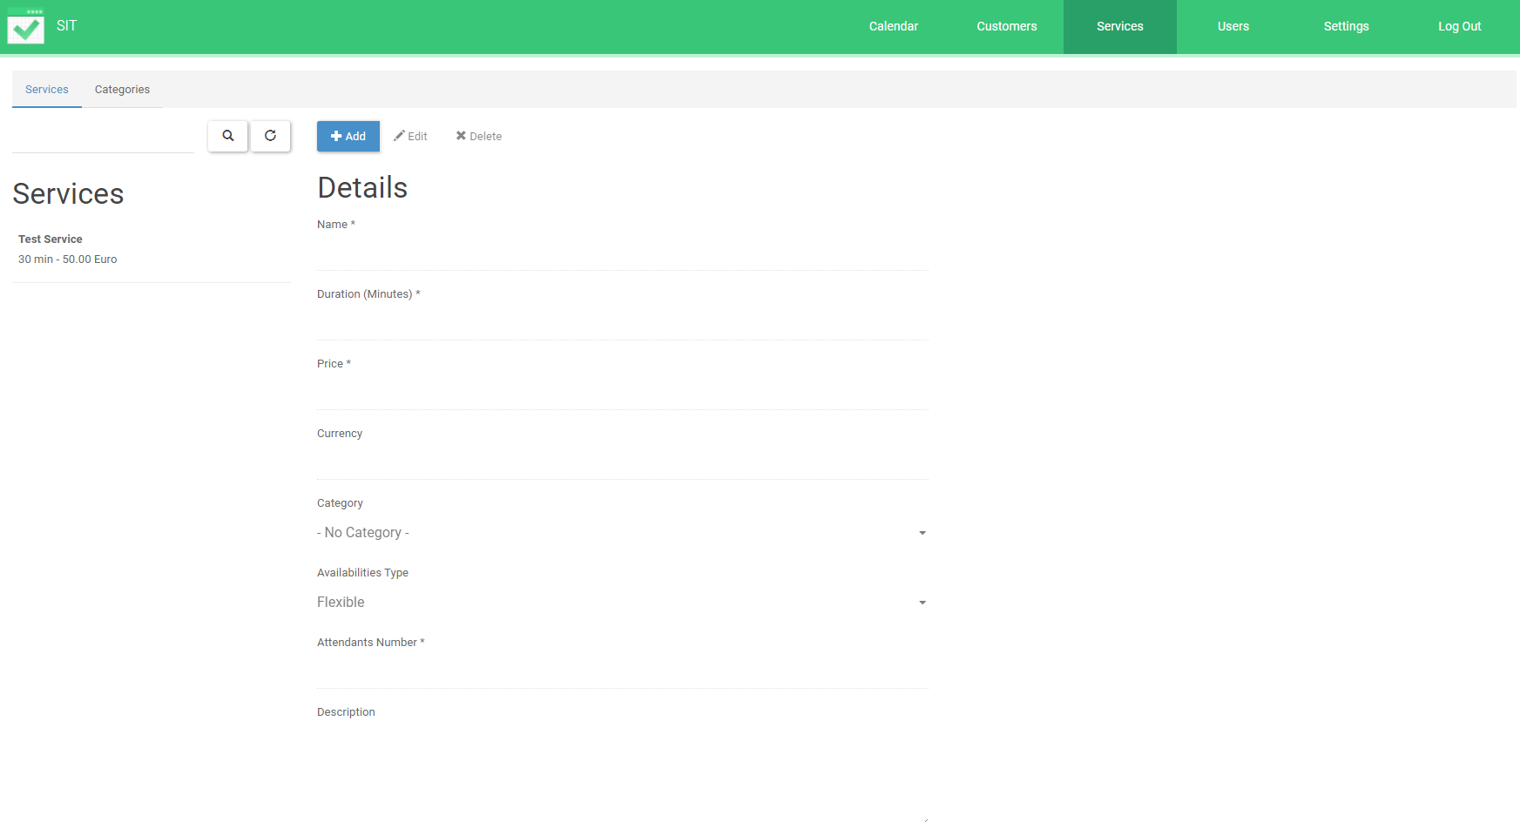

Services Button

## Check or edit service:

Select a previously added service on the left of the page. This will populate all the fields with the service details. Check and edit the service details then click save if any changes are made. Blue +Add button will change to Save button when information is added or edited.

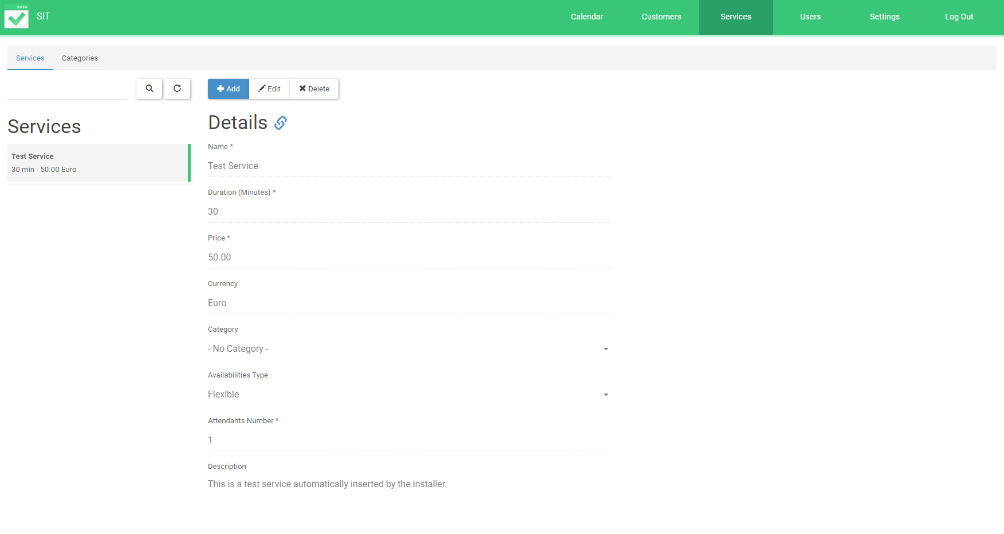Add providers:  
  
Click on Users in the top of the screen. This will bring the user to the Providers page. Click +Add at the top of this page. The provider details can now be added. First name, Last name, email, phone number, mobile number, address, city, state, Zip/Post code, Username, Password. Fields with a * are required. Click save when changes are made. Blue +Add button will change to Save button when information is added or edited.

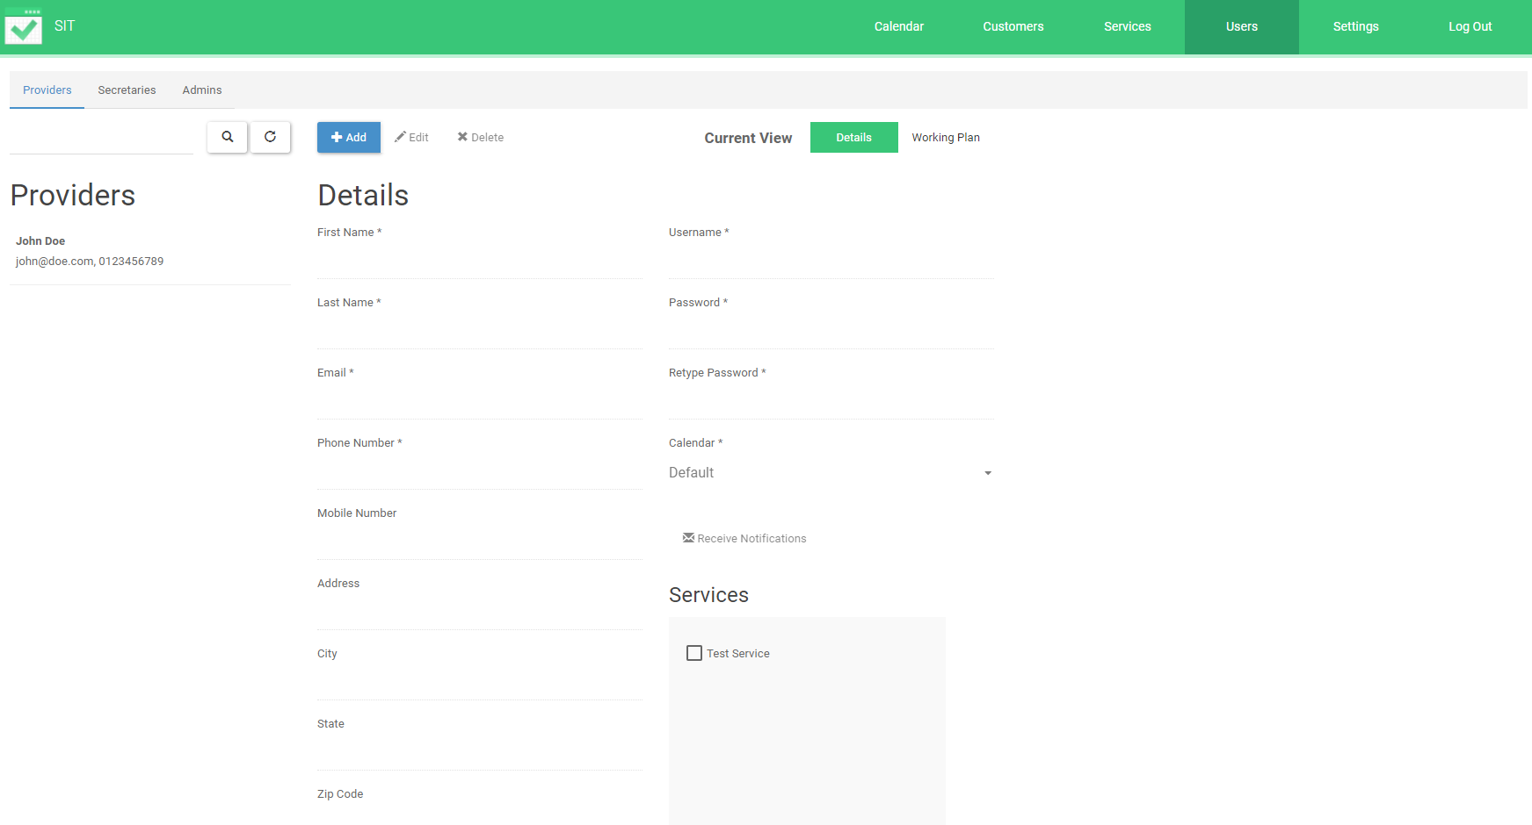

Users Button

## Check/Edit providers details:

Select a previously added provider on the left of the page. This will populate all the fields with the provider details. Check and edit the service details then click save if any changes are made. Click save when changes are made. Blue +Add button will change to Save button when information is added or edited.

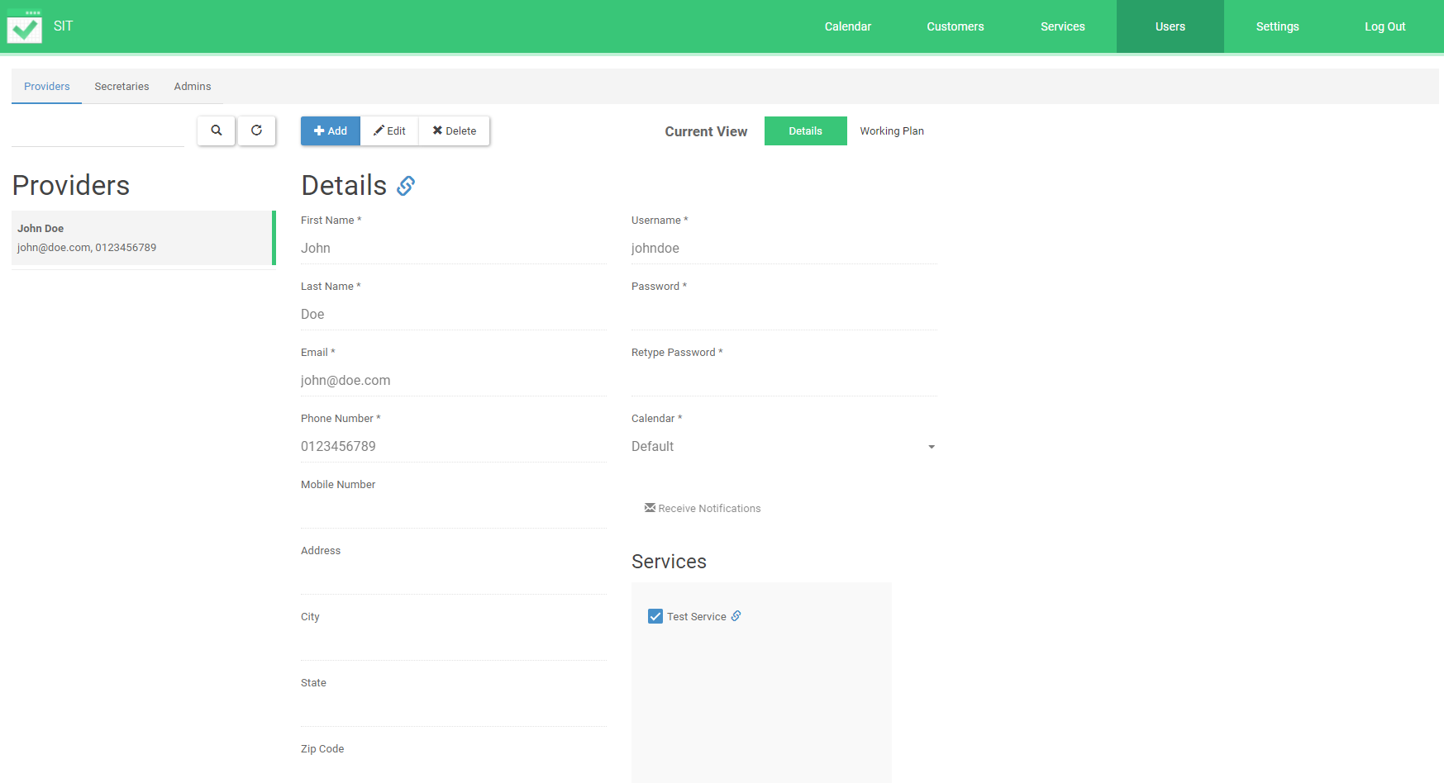

## Settings General:

Click on Settings in the navbar. The general settings tab in grey at the top right will open automatically. Check or edit the information in fields below then click save.

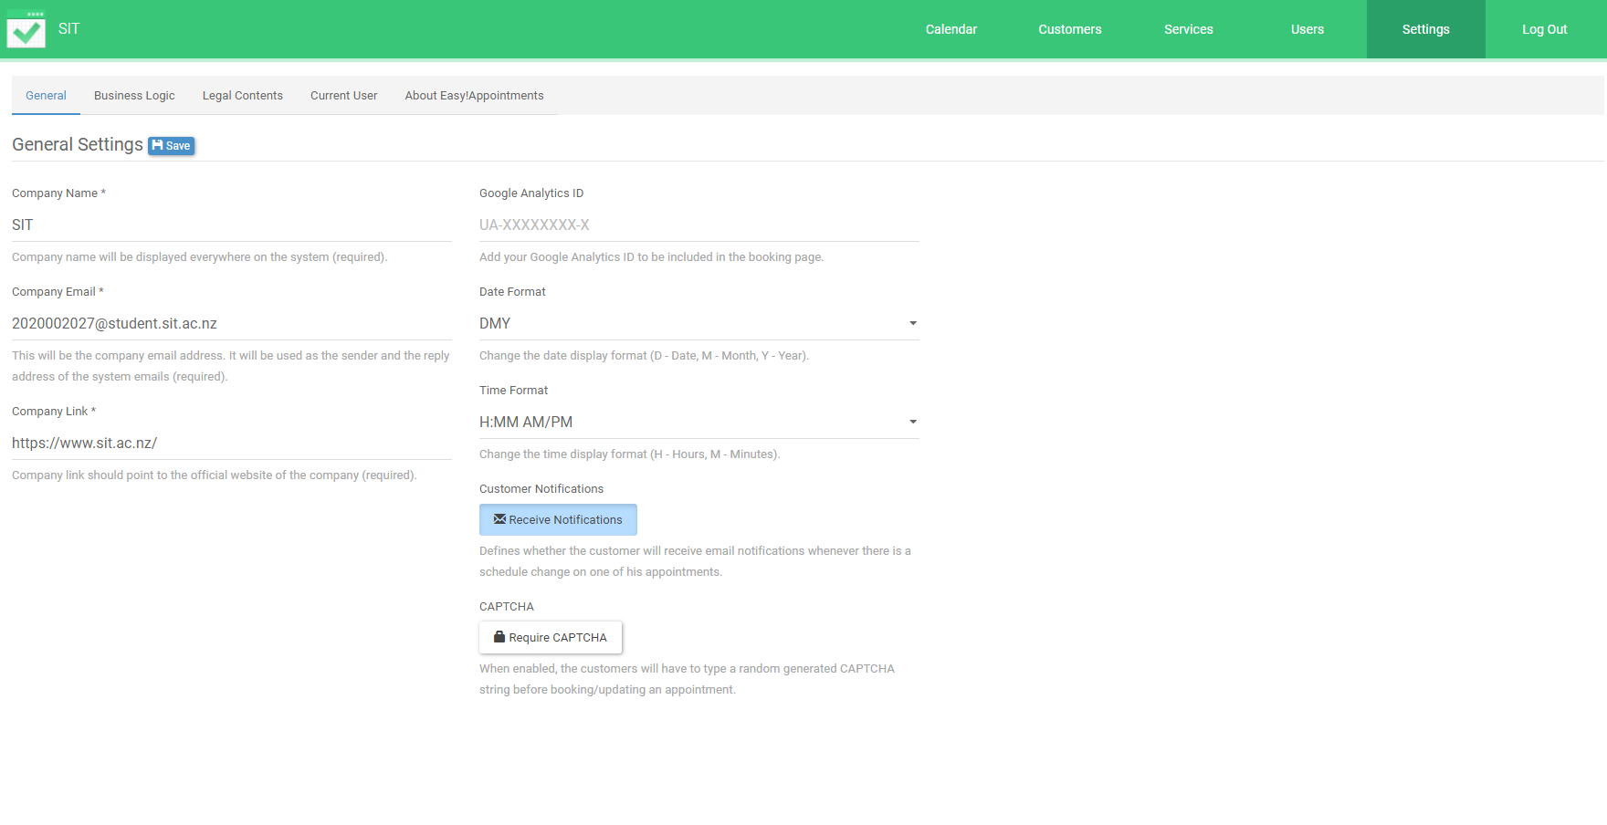

Settings

Settings business logic:

Click on the Business Logic tab at the top. In this page you can adjust what hours you are the company is available for business. Deselect days on the left which are not available and on the add meal breaks using the +Add Break button above.

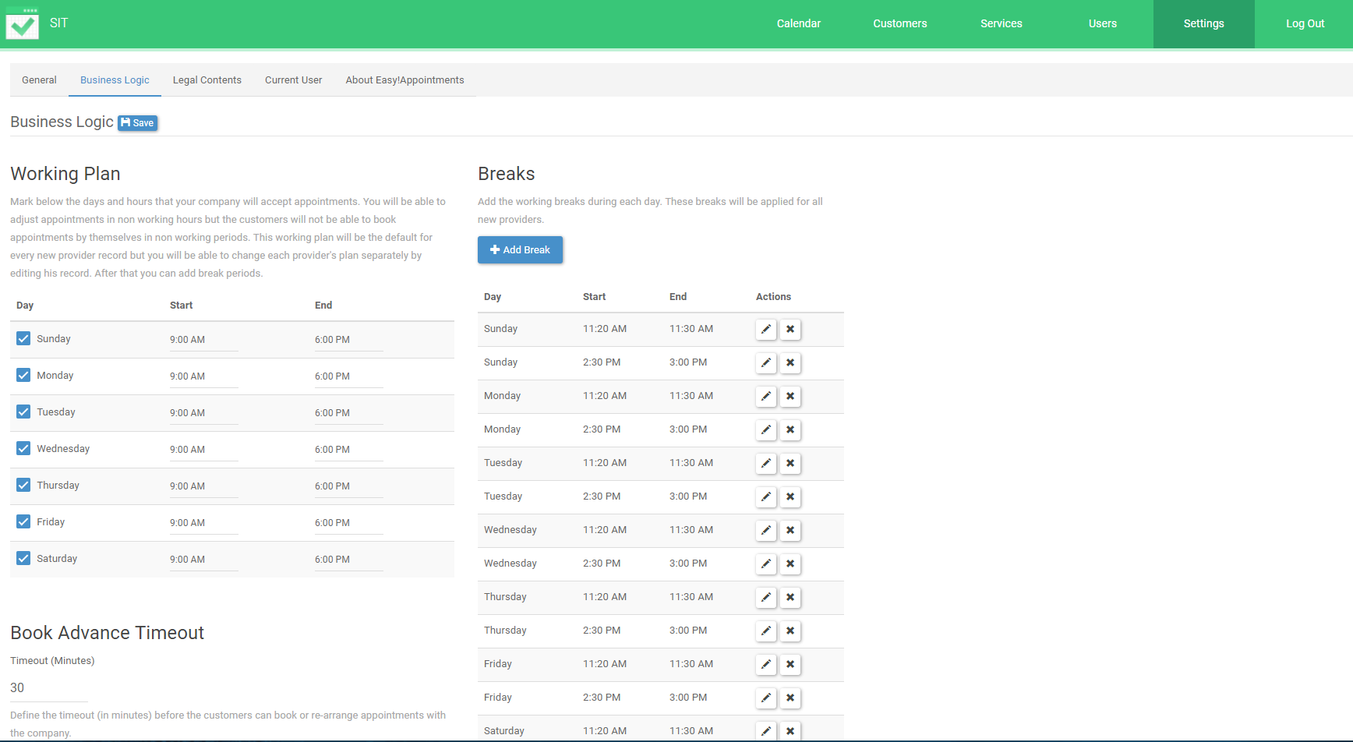

Business Logic

Settings legal contracts:

Click on Legal Contents at the top. This will open the page where you can add legal notices about Cookies, Terms and conditions and privacy policy. If required fill out a legal notice then select the box below the name for it to appear on the front end of the site.

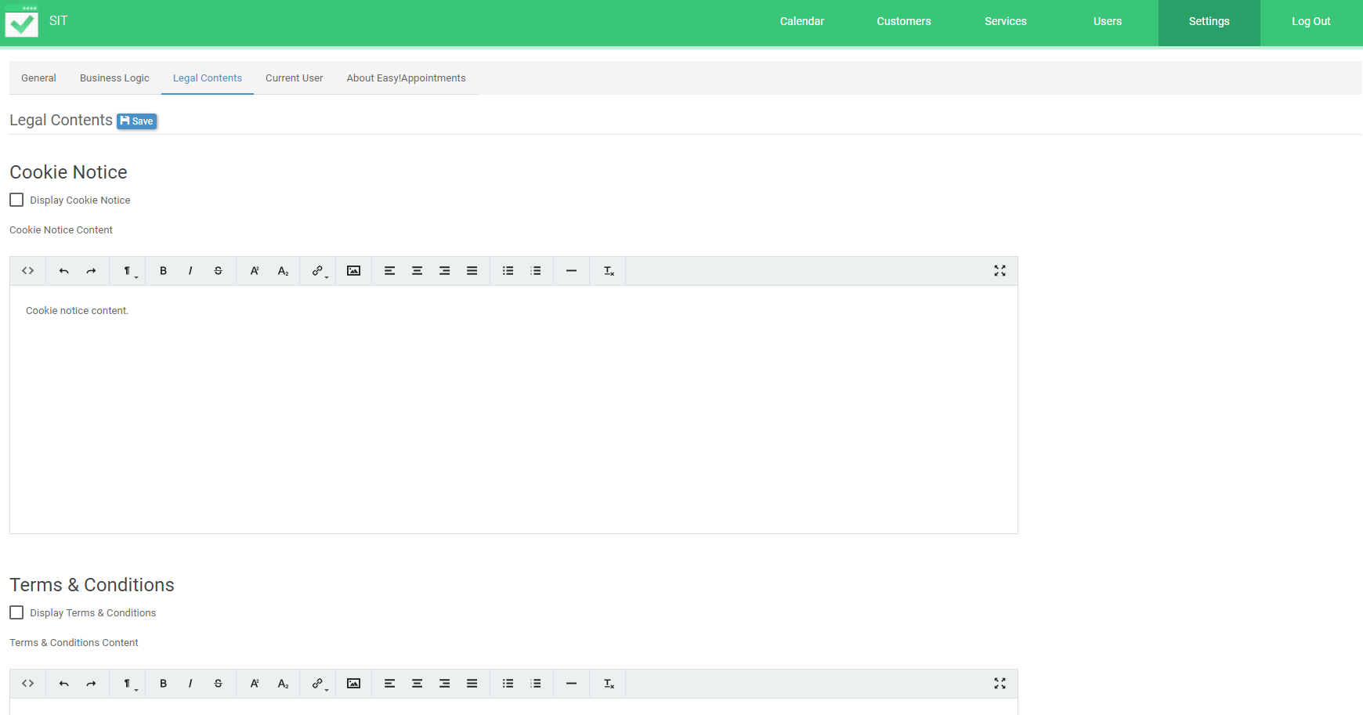

Legal Contents

Settings Current User:  
  
Select the Current User tab at the top. This will open the personal information page. Check or edit the details in the fields below then click save. All the fields with * are required.

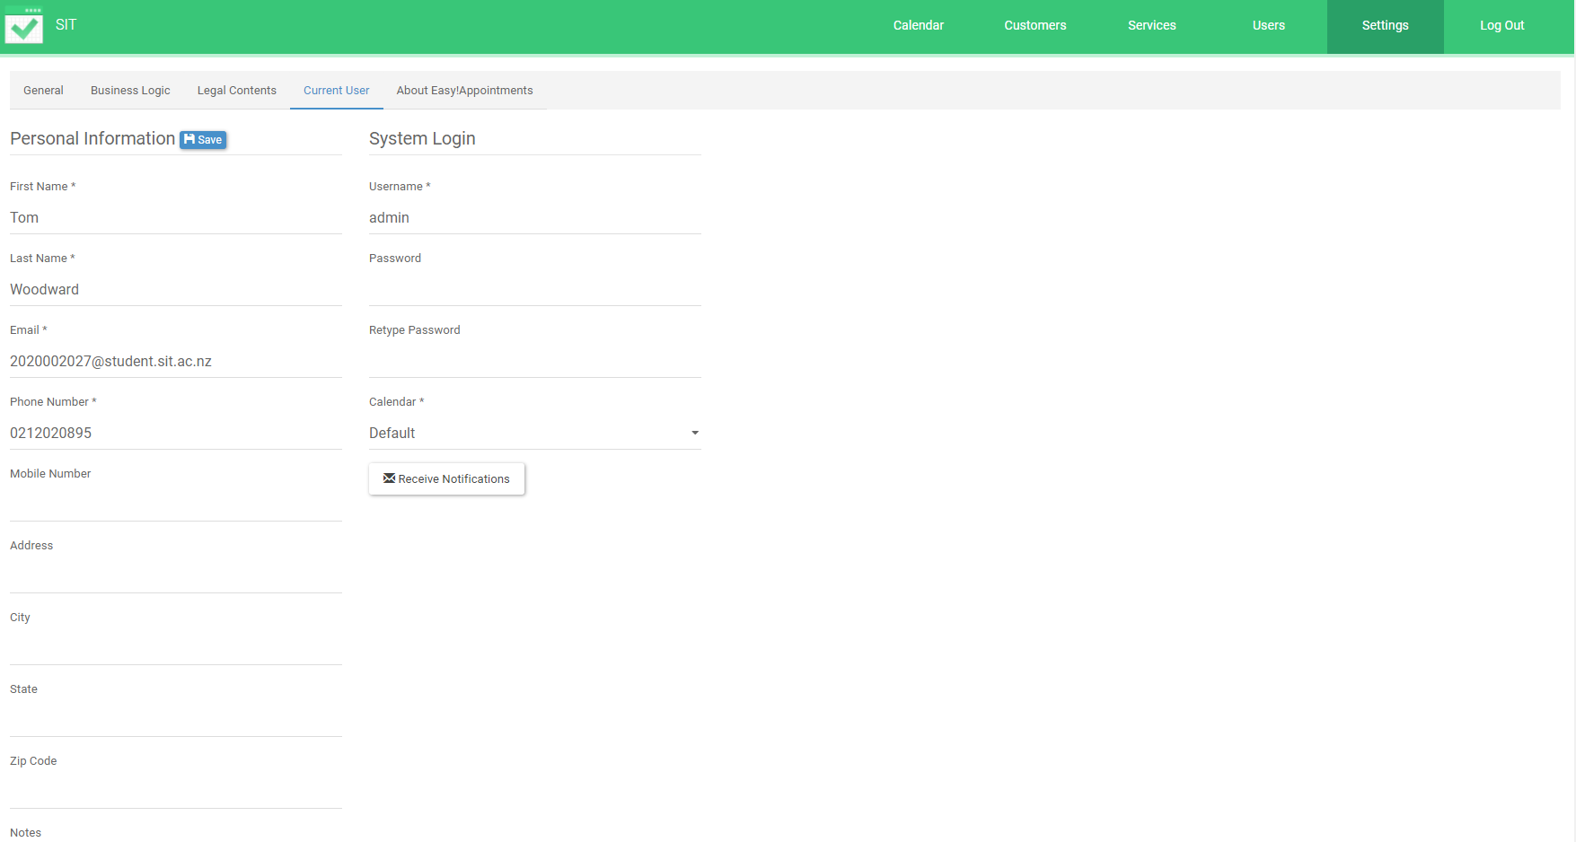

Current User

Settings About Easy Appointments:

Click About Easy!Appointments tab to open the about page. In this can find information about the software.

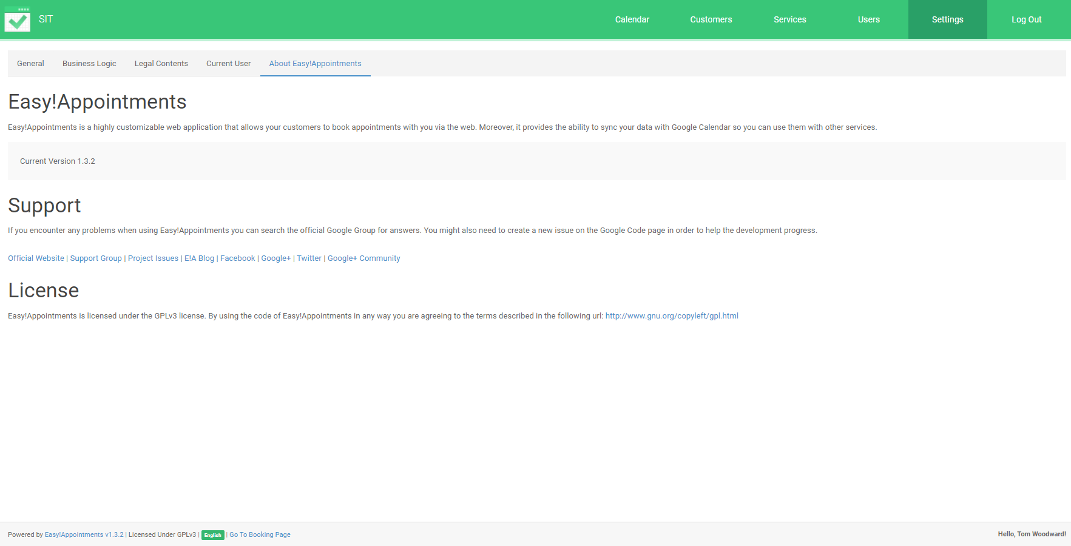

About